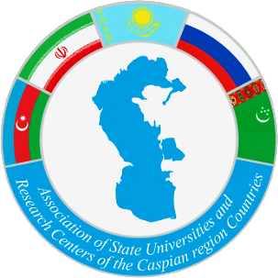 | 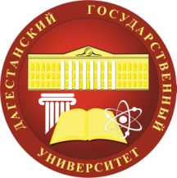

APPLICATION FORM
Participant in the anniversary 25th General Assembly of the Association of State Universities and Research Centers of the Caspian Countries, Makhachkala, November 01-04, 2023
1.
The sending organization (name of the University)
Full name of the Head of the delegation
Position
2.
Information about the delegation
№ | Full name of the participants | Position | Participation as a speaker (if yes, specify the discussion platform and topic of the report) | e-mail, phone number
1.
2.
3. Discussion platform of 25th anniversary General Assembly of the Association of State Universities and Research Centers of the Caspian Countries:
- «International transportation corridor «North-South»: integration of science and education»;
- «Monitoring, management and conservation of biological diversity of the South of Russia and the Caspian region»;
- «Social, historical and multicultural heritage of the peoples of the Caspian region»;
- «Transport and logistic»;
- «Cybersecurity»;
- «Tourism»;
- «Artificial intelligence».
4. Passport (Attached copy of passport)

